2025 Elevate BEACH Camp
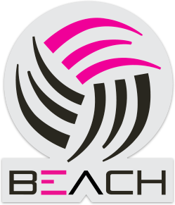
Club registration and release form

PLEASE WRITE LEGIBLY

ATHLETE INFORMATION:
First name:
Last name:
Birthdate:
Uniform Top Size:
Sweat Top Size:
Short Size:
Shoe Size:
Date completing this form: Athlete age today: Athlete age on Sept 1st 2024: AAU #:
Current school:
Current grade:
Primary care physician and phone number:
Insurance carrier, name of plan:
[ ] I am available for 100% of all practices, June10-July01 unless sick/injured.
If not please explain

PARENT / GUARDIAN INFORMATION:
Name(s):
Relationship to athlete:
Cell number(s):
Home phone:
Primary E-mail(s):
Mailing address:
Street address:

Beach Season:
The regular season runs from May – July

Waiver, release, fee agreement and AAU Liability Insurance Information:
I hereby indemnify and hold harmless Elevate Volleyball Club, LLC and its agents and employees from any and all claims arising out of injury, accidents, or illness to my child while participating in any clinics, tryouts, practices and tournaments. I authorize Elevate Volleyball Club, LLC to act for me according to their best judgment in any emergency requiring medical attention. I understand insurance coverage is available and mandatory for my athlete through Amateur Athletic Union (http://aausports.org/). If my athlete is accepted and enrolled on a tournament team I agree to pay the fees associated with the beach club season by the due dates listed above. If I do not pay the club fees by the date due, I also agree to pay for any fees associated with third party collection efforts. I authorize EVBC to publish appropriate media of my athlete on the EVBC website without expectation for reimbursement.

Parent / Guardian Signature and Date:

_______________________________________________________________________

